ASWANTH N N
192424123

Experiment 1: Regular Expressions in Python
Aim
To demonstrate the use of regular expressions in Python to match and search for patterns in text.
Algorithm
- Import the re module.
- Store the input text.
- Search for a phone number using re.search().
- Search for an email address using re.search().
- Find all words starting with a specific letter using re.findall().
- Display the matched results.
Code
import re
text = "My phone number is 9876543210 and my email is user@gmail.com"
# Search for a phone number
phone = re.search(r"\d{10}", text)
if phone:
print("Phone Number:", phone.group())
# Search for an email
email = re.search(r"\S+@\S+", text)
if email:
print("Email:", email.group())
# Find all words starting with 'p'
words = re.findall(r"\bp\w+", text)
print("Words starting with 'p':", words)
Output
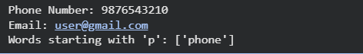
Result
The program successfully demonstrated the use of regular expressions to search and match patterns such as phone numbers, email addresses, and words in the given text.

Experiment 2: Finite State Automaton
Aim
To implement a basic Finite State Automaton (FSA) that recognizes strings ending with "ab".
Algorithm
- Define the automaton with different states.
- Read the input string character by character.
- Change the state based on the current character.
- Continue until all characters are processed.
- Check whether the final state is the accepting state.
- Display whether the string is accepted or rejected.
Code
def finite_state_automaton(string):
state = 0
for ch in string:
if state == 0:
if ch == 'a':
state = 1
else:
state = 0
elif state == 1:
if ch == 'b':
state = 2
elif ch == 'a':
state = 1
else:
state = 0
elif state == 2:
if ch == 'a':
state = 1
else:
state = 0
return state == 2
text = input("Enter a string: ")
if finite_state_automaton(text):
print("Accepted (Ends with 'ab')")
else:
print("Rejected")

Output
Result
The Finite State Automaton successfully recognized strings ending with "ab" and rejected strings that did not satisfy the required pattern.

Experiment 3: Morphological Analysis using NLTK
Aim
To perform morphological analysis using the NLTK library in Python.
Algorithm
- Import the required NLTK modules.
- Download the required NLTK resources.
- Tokenize the input sentence into words.
- Perform Part-of-Speech (POS) tagging.
- Apply lemmatization to obtain the base form of each word.
- Display the original word, POS tag, and lemma.
Code
import nltk
from nltk.stem import PorterStemmer, WordNetLemmatizer

nltk.download('wordnet')

stemmer = PorterStemmer()
lemmatizer = WordNetLemmatizer()

word = input("Enter a word: ")

print("Original Word :", word)
print("Stemmed Word :", stemmer.stem(word))
print("Lemmatized Word:", lemmatizer.lemmatize(word))
Output
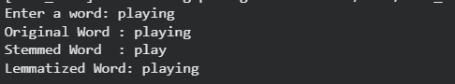Result
The program successfully performed morphological analysis by identifying the base form (lemma) of each word using POS tagging and lemmatization.

Experiment 4: Finite State Machine for Morphological Parsing
Aim
To implement a Finite State Machine for generating plural forms of English nouns.
Algorithm
- Accept a singular noun as input.
- Check whether the noun ends with s, x, z, ch, or sh.
- If true, append "es".
- Otherwise, check whether the noun ends with y preceded by a consonant.
- If true, replace y with "ies".
- Otherwise, append "s".
- Display the plural form.
Code
if noun.endswith(("s", "x", "z", "ch", "sh")):
return noun + "es"
elif noun.endswith("y") and noun[-2] not in "aeiou":
return noun[:-1] + "ies"
else:
return noun + "s" def pluralize(noun):
word = input("Enter a singular noun: ")
print("Plural Form:", pluralize(word))

Output
Result
The Finite State Machine successfully generated the correct plural forms of English nouns based on simple morphological rules.

Experiment 5: Porter Stemmer Algorithm
Aim
To perform word stemming on a list of words using the Porter Stemmer algorithm available in the NLTK library.
Algorithm
- Import the required NLTK library.
- Create a PorterStemmer object.
- Store a list of words.
- Apply the stem() method to each word.
- Display the original and stemmed words.
Code
from nltk.stem import PorterStemmer

# Create Porter Stemmer object
stemmer = PorterStemmer()

# List of words
words = ["running", "playing", "studies", "happily", "connected", "fishing"]

print("Original Word\tStemmed Word")
print("-" * 30)

for word in words:
print(word, "\t\t", stemmer.stem(word))
Output
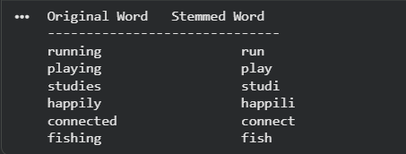

Result
The program successfully applied the Porter Stemmer algorithm to reduce words to their stem forms using the NLTK library.

Experiment 6: Basic N-gram Model with Morphological Analysis using NLTK
Aim
To implement a basic Bigram (2-gram) model for text generation and perform morphological analysis using NLTK without using the Porter Stemmer.
Algorithm
- Import the required NLTK modules and the random library.
- Tokenize the input sentence into individual words.
- Perform POS tagging and lemmatization to obtain the base form of each word.
- Build a Bigram model using consecutive lemmatized words.
- Randomly select a starting word.
- Generate text by choosing the next word based on the Bigram model.
- Display the morphological analysis and the generated text.
Code
import random
import nltk
from nltk.stem import WordNetLemmatizer
from nltk.tokenize import word_tokenize
from nltk.corpus import wordnet

# Download resources (Run only once)
nltk.download('punkt')
nltk.download('wordnet')
nltk.download('averaged_perceptron_tagger')

# Create lemmatizer
lemmatizer = WordNetLemmatizer()

# Input text
text = "The boys are running and the girls are writing letters."

# Tokenize
words = word_tokenize(text)

# POS tagging
pos_tags = nltk.pos_tag(words)

# Convert NLTK POS tags to WordNet POS
def get_wordnet_pos(tag):
if tag.startswith('J'):
return wordnet.ADJ
elif tag.startswith('V'):
return wordnet.VERB
elif tag.startswith('N'):
return wordnet.NOUN
elif tag.startswith('R'):
return wordnet.ADV
else:
return wordnet.NOUN

print("Morphological Analysis")
print("-----------------------")

lemmatized_words = []

for word, tag in pos_tags:
if word.isalpha():
lemma = lemmatizer.lemmatize(word, get_wordnet_pos(tag))
lemmatized_words.append(lemma)
print(f"{word:12} -> {lemma}")

# Create Bigram Model
bigram = {}

for i in range(len(lemmatized_words) - 1):
current = lemmatized_words[i]
next_word = lemmatized_words[i + 1]

if current not in bigram:
bigram[current] = []

bigram[current].append(next_word)

# Generate text
current = random.choice(lemmatized_words)
generated = [current]

for i in range(9):
if current in bigram:
current = random.choice(bigram[current])
generated.append(current)
else:
break

print("\nGenerated Text")
print("--------------")
print(" ".join(generated))
Output
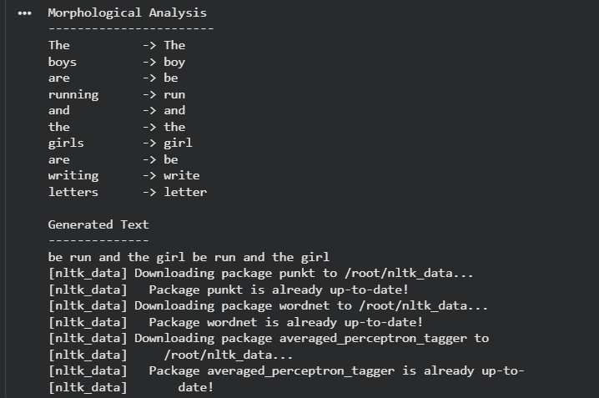
Result
The program successfully performed morphological analysis using lemmatization and generated text using a Bigram (2-gram) model. The generated text was created based on the word pairs learned from the input sentence.

